**Planning February -2019**

**BV461: BB5216:** 3x2217-B20; 3x2219-B8

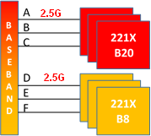

**BV463: BB5216:** 2x2217-B20; 2x2219-B8

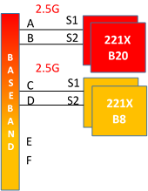

**BV464: BB5216:** 3x2219-B8 (MM LTE&GSM)

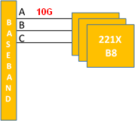

**BX161, BX292, BX316, BX317, BX347, BX550: BB5212:** 3x2217 (existing); 3x2219-B3 (new)

Before:

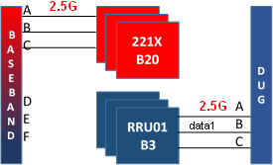

After:

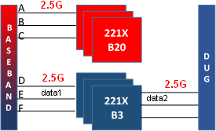

**BX338, BX144: BB5212:** 4x2217-B20 (existing); 4x2219-B3 (new)

Before;

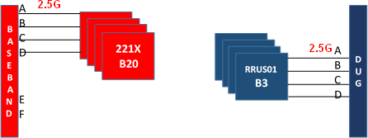

After:

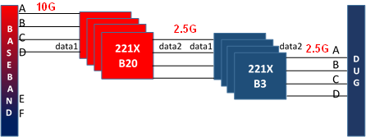

**BX572: BB5212:** 3x2217-B20 (existing); 3x2219-B3 (new)

Before

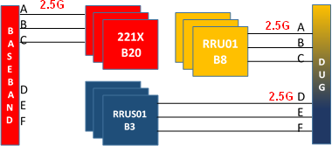

After

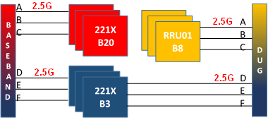

**BX574, BX630: BB5212:** 2x2217-B20 (existing); 2x2219-B3 (new)

Before

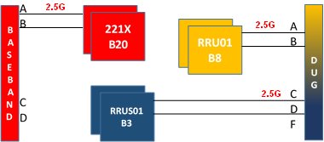

After:

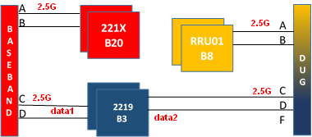

**BA346, BA471, BX351, BX101: BB5212:** 4x2217-B20 (existing); 3x2219-B3 (new)

Before

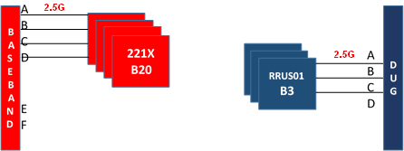

After

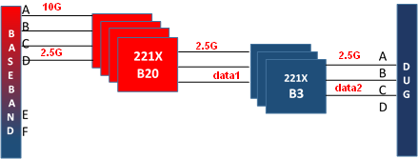

**BX268: DUS31:** 3x2217-B20 (existing); 3x2219-B3 (new)

Before

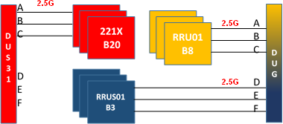

After

