**Planning w07 -2019**

**BV461: BB5216:** 3x2217-B20; 3x2219-B8

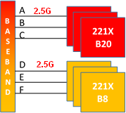

**BV463: BB5216:** 2x2217-B20; 2x2219-B8

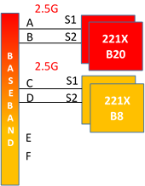

**BV464: BB5216:** 3x2219-B8 (MM LTE&GSM)

