CLUSTER AB23
CJ105: BB5216: 2xR2217-B20, 2xR2219-B1, 2XR2219-B8
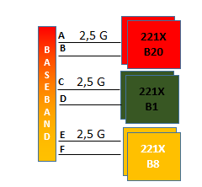
CJ117: BB5216: 3xR2217-B20, 3xR2219-B1, 3XR2219-B8
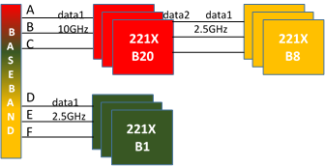
CJ409: BB5216: 4xR2217-B20, 4xR2219-B1
BB5212: 3XR2219-B8
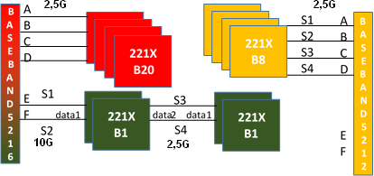

CJ439, CJ572, CJ815, CJ821: BB5216: 3XR2219-B8 (MM UMTS&GSM)
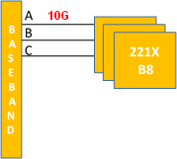
CJ442: BB5216: 2xR2219-B1, 2XR2219-B8
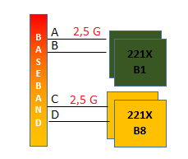
CJ783: BB5216: 3xR2217-B20, 2xR2219-B1, 3XR2219-B8 (MM UMTS&GSM S3)
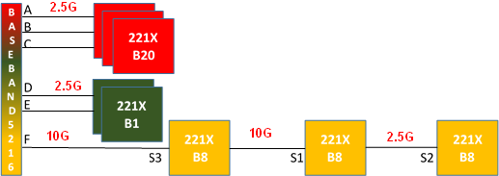
CJ812: BB5216: 4xR2219-B8 (MM UMTS&GSM)
