Schemas swap4G ZTE

CJ001, CJ332: BB5216: 4x2242-B1B3 (MM with DCS)
BB5212: 4x2219-B8, 4x2242-B1B3 (MM with LTE)
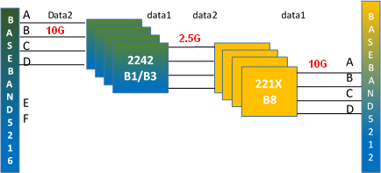
TM187: BB5216: 4x2242-B1B3
BB5212: 4x2219-B8
